EXPNO 10: CREATE A SNAPSHOT OF A VM AND TEST IT BY LOADING THE PREVIOUS VERSION/CLONED VM DATE:
AIM: To create a snapshot of a vm and test it by loading the previous version/cloned vm
PROCEDURE:
step 1: go to vm ware workstation.
step 2: create files on desktop.
step 3: click on vm and selects snapshot-> take snapshot.
step 4: snapshot is being done
IMPLEMENTATION:
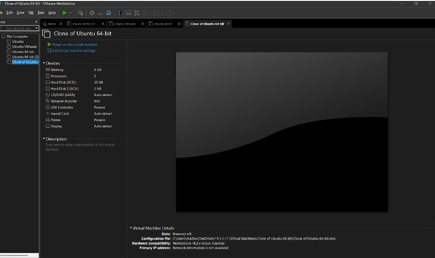
RESULT: thus,it was successfully completed

